
Kashmir Luxury Tour.
( 06 Nights / 07 Days Srinagar – Sonmarg – Pahalgam – Gulmarg)
Kashmir was coined the term "Paradise on Earth" by the Mughal Emperor Jahangir and truely so, it mesmerising tourists all over the world. Kashmir is famous for its juicy apples and the rare saffron fibres. It is also world famous for its beauty and offers the green hills and meadows of Gulmarg and Pahalgam. The Dal Lake, which is considered unanimously as India's most beautiful lake is in Kashmir. The Dal lake remains frozen for most part of the year and attracts tourists during summer, when the ice melts away and makes way for boat houses and numerous water activities.
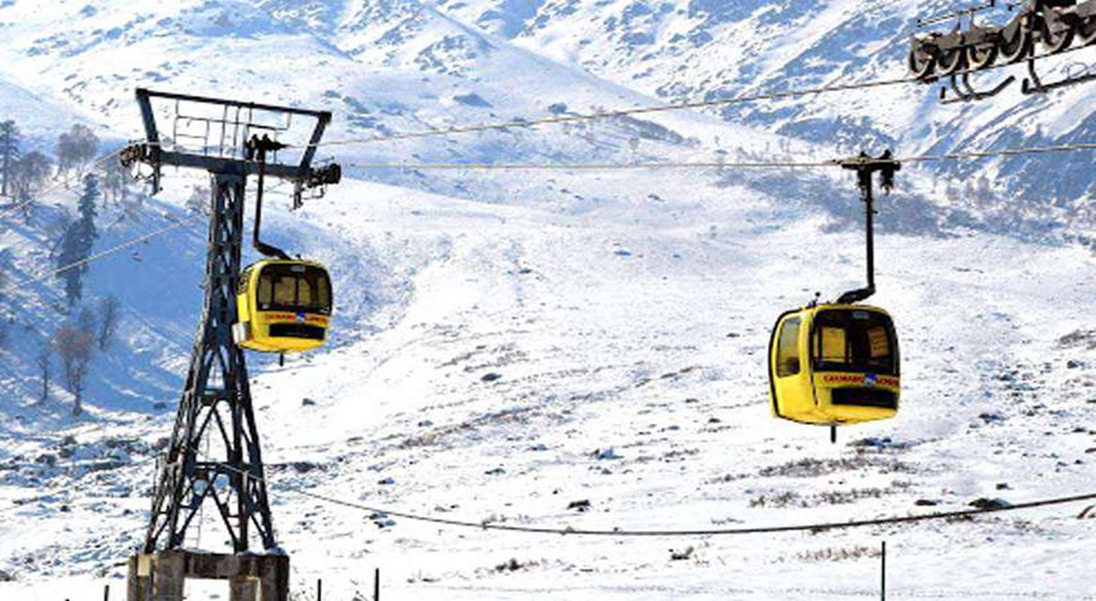

The main tourist attractions of the Kashmir valley are Srinagar that houses the popular houseboats, Gulmarg that has a ski resort, Sonmarg, Pahalgam and Amarnath Temple. An annual pilgrimage is made to the Amarnath cave by lakhs of Hindu devotees on challenging mountainous terrain to see an ice stalgamite formed inside the cave. One watch the majestic view of the snow capped himalayas against the cerulean sky in Sonmarg. Gulmarg is one of the most popular ski resort in India and also the home to world's highest golf course. The cuisine of Kashmir is in a complete contrast to the rest of India. Some other tourist attractions are Jama Masjid, Shalimar garden, Chashmashahi, Dachigam National Park, Shankaracharya Temple, Martand Sun Temple and Nishat garden.
Duration : 06 Nights / 07 Days
Destination Covered : Srinagar – Sonmarg – Pahalgam – Gulmarg

Itinerary
Day 01: Arrival at Srinagar & Local Sightseeing
On arrival at Srinagar Airport, meet our representative and transfer to hotel, check-in the hotel & after fresh-n-up go for Shikara Ride in the Dal. Later we will do some half a day of Local Sightseeing of famous Mughal Gardens With terraced lawns, cascading fountains, paint-box-bright flowerbeds with the panorama of the Dal in front of them – the three Mughal Gardens of Chesmashahi, Nishat and Shalimar are the Mughal Emperors’ concept of paradise and are today very popular places for picnics and excursions. In the Evening visit Shankaracharya temple, Hazratbal Shrine. Later transfer to hotel for dinner and overnight stay in hotel.

Day 02: Srinagar – Sonamarg – Srinagar (80 kms. / 2 hrs)
Second day, post delicious breakfast & transfer to Sonamarg. Enroute you can explore the beauty of certain spots & continue towards Sonar which also known as “meadow of gold”. You can visit Thajiwas Glacier which covered with snow throughout the year. After exploring the Sonmarg return back to Srinagar and Overnight Stay at Hotel.

Day 03: Srinagar – Pahalgam (97 kms. / 3-4 hrs)
Third day in the early morning after breakfast drive towards Pahalgam. Enroute visit Saffron fields of Pampore , Awantipura ruins and Mattan temple, Finaly reach Pahalgam which is a beautiful spots where more than Bollywood movies are shooted, Later back to the hotel for Dinner & Overnight Stay in Pahalgam.

Day 04: Pahalgam Sightseeing
Fourth day, in the morning after breakfast, you can trek or hire ponies to the meadow at Baisaran (5 km) you can also hire local car and visit Aru , Chandanwari and Betab Valley. Back to the hotel for Dinner & Overnight Stay.

Day 05: Pahalgam – Gulmarg (152 kms. / 4-5 hrs)
In the morning after breakfast, drive to Gulmarg. Its take approx 4 to 5 Hrs to reach Gulmarg. On arrival at Gulmarg, check-in at the hotel & After fresh-n-up, you can visit the Famous Golf Course, St. Marry Church and Rani Temple by Trek or you can hire Pony. Later back to hotel for Dinner & Overnight Stay.
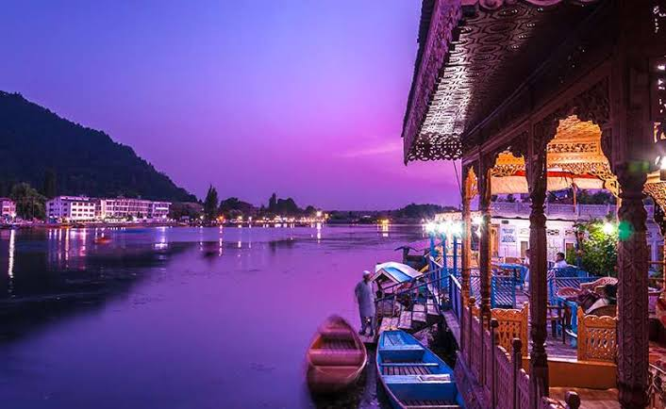

Day 06: Gulmarg – Srinagar (52 kms. / 2 Hrs.)
Next Day, in the morning after breakfast, you can spend half day with Gondola (Cable car) ride which is highest in Asia. It has 2 phases. The first stage transfers from the Gulmarg resort at 2,600 m (8,530 ft) to Kongdoori Station in the bowl-shaped Kongdori valley. The second stage of the ropeway, which has 36 cabins and 18 towers, takes skiers to a height of 3,747 m (12,293 ft) on Kongdoori Mountain, a shoulder of nearby Afarwat Peak (4,200 m(13,780 ft)). Later drive to Srinagar. Dinner & Overnight stay at Houseboat.

Day 07: Departure
In the morning after delicious breakfast, check-out from the hotel and drive to Airport (45 mins) with sweet memories. Guests are advised to reach Airport 2 hrs before the departure time.

